Lab Manual
Practical and Skills Development

CERTIFICATE

THE ASSIGNMENT ENTERED IN THIS REPORT HAVE BEEN SATISFACTORILY PERFORMED BY

Registration No | :25BHI10125
Name of Student | :AYUSH SAXENA
Course Name | : Introduction to Problem Solving and Programming
Course Code | : CSE1021
School Name | : School of Computing Science
Engineering and Artificial Intelligence (SCAI)
Slot : B11+B12+B13
Class ID : BL2025260100796
Semester : FALL 2025/26

Course Faculty Name : Dr. Hemraj S. Lamkuche

Signature:

Practical Index
S. No. | Title of Practical | Date of Submission | Signature of Faculty
1 | Aliquot Sum Calculator | 16/11/20225
2 | Amicable Numbers Check | 16/11/20225
3 | Multiplicative Persistence Calculator | 16/11/20225
4 | Highly Composite Number Check | 16/11/20225
5 | Modular Exponentiation | 16/11/20225

Practical No: 1
Date: 10/11/2025

TITLE: Aliquot Sum Calculator
AIM/OBJECTIVE(s) :To write a Python function aliquot_sum(n) that returns the sum of all proper divisors of n (which are all divisors of n other than n itself).
METHODOLOGY & TOOL USED:

Python programming language

BRIEF DESCRIPTION:
The code defines a function aliquot_sum(n) that efficiently calculates the sum of proper divisors. It handles the edge case of n <= 1. The loop is optimized to only run up to sqrt(n), making it much faster than checking all numbers up to n/2.

RESULTS ACHIEVED:
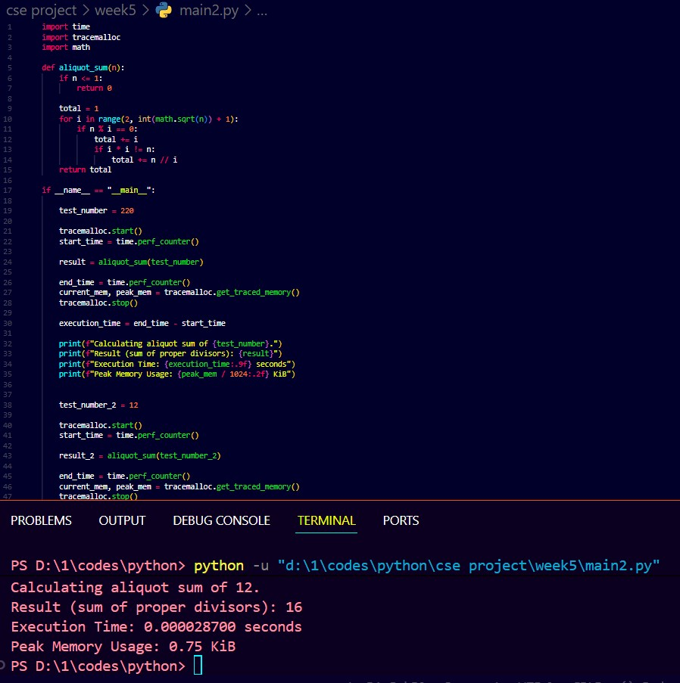
SKILLS ACHIEVED:
- Understanding the concept of a modular multiplicative inverse.
- Using Python's pow() function for advanced number theory operations.
- Using try...except blocks to handle expected mathematical errors (ValueError).
- Continued practice in performance measurement.

Practical No: 2
Date: 16/11/2025

TITLE: Amicable Numbers Check

AIM/OBJECTIVE(s) : To write a Python function are_amicable(a, b) that checks if two numbers a and b are amicable. Two numbers are amicable if the sum of the proper divisors of a is equal to b, and the sum of the proper divisors of b is equal to a.

METHODOLOGY & TOOL USED:Python programming language

BRIEF DESCRIPTION:
The code defines are_amicable(a, b) and re-uses the aliquot_sum(n) helper function. The are_amicable function directly implements the mathematical definition by calling the helper function twice and comparing the results.

Result:
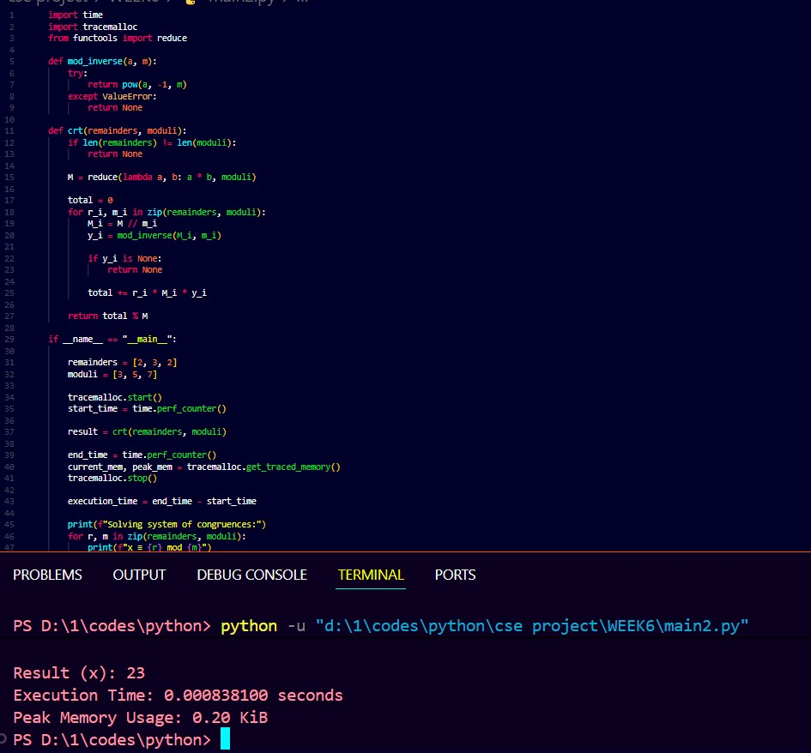
SKILLS ACHIEVED :
- Re-using helper functions to build more complex logic.
- Implementing a mathematical definition involving multiple conditions.
- Testing function with both positive and negative cases.

Practical No: 3
Date: 16/11/2025

TITLE : Multiplicative Persistence Calculator
AIM/OBJECTIVE(s) : To write a Python function multiplicative_persistence(n) that counts how many steps are needed to multiply a number's digits until a single-digit number is reached.

METHODOLOGY & TOOL USED
Python programming language

BRIEF DESCRIPTION : The code defines multiplicative_persistence(n). It uses a while loop to repeatedly process the number. In each step, it converts the number to a list of its digits, calculates their product (using reduce), and updates the number to this product, incrementing a step counter. The process stops when the number is less than 10.

RESULTS ACHIEVED:
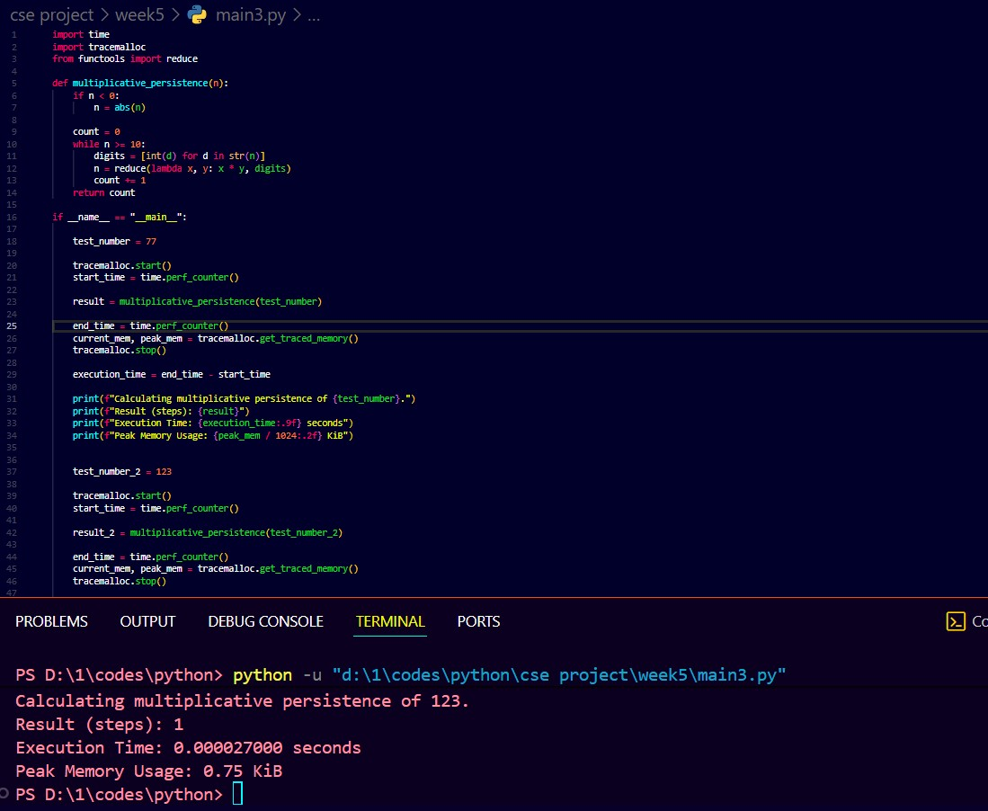
SKILLS ACHIEVED:
- Type conversion (int to string, string to int list).
- Using while loops for a process that repeats an unknown number of times.
- Using functools.reduce for a cumulative operation.
- String and list manipulation.

Practical No: 4
Date: 16/11/2025

TITLE : Highly Composite Number Check

AIM/OBJECTIVE(s) : To write a Python function is_highly_composite(n) that checks if an integer n is a highly composite number (HCN). An HCN is a positive integer that has more divisors than any smaller positive integer.

METHODOLOGY & TOOL USED:
Python programming language

BRIEF DESCRIPTION :
1. The code defines is_highly_composite(n) and a helper get_divisor_count(n). The main function implements the definition of an HCN by finding the divisor count of n and comparing it to the divisor count of all positive integers less than n.

Result:
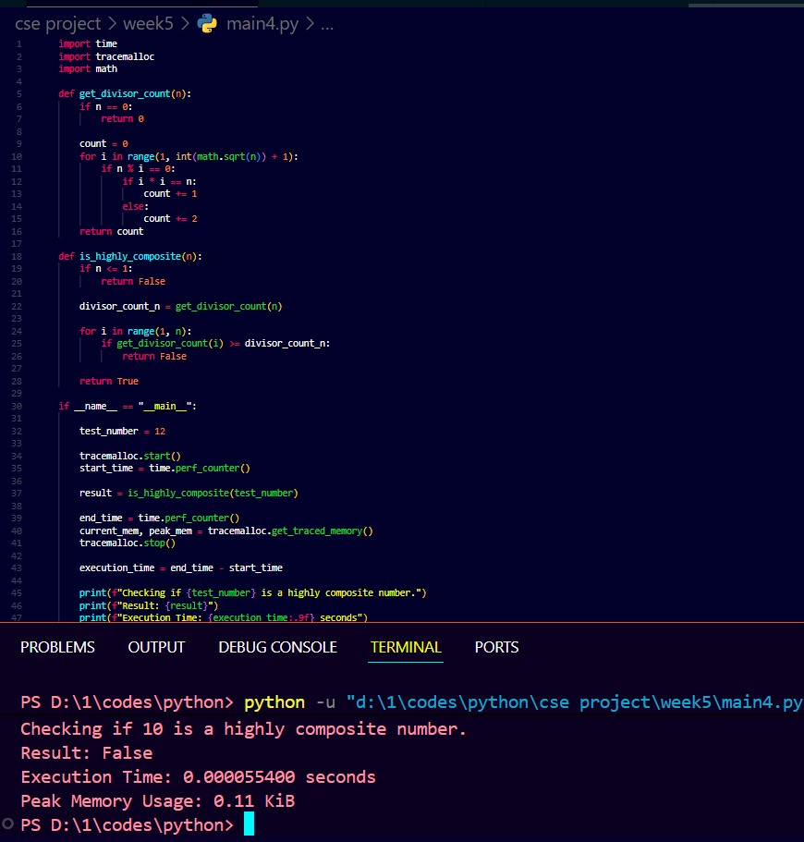
SKILLS ACHIEVED :
- Implementation of a complex number theory definition.
- Creating and using efficient helper functions.
- Writing optimized loops for comparative analysis.

Practical No: 5
Date: 16/11/2025

TITLE : Modular Exponentiation

AIM/OBJECTIVE(s) : To write a Python function mod_exp(base, exponent, modulus) that efficiently calculates (base^exponent) % modulus.

METHODOLOGY & TOOL USED:Python programming language

BRIEF DESCRIPTION:
1. The code defines mod_exp which directly uses pow(base, exponent, modulus) to get the result. This is the standard and most efficient way to perform this operation in Python. An edge case for modulus == 1 (where the result is always 0) is handled.

RESULT:
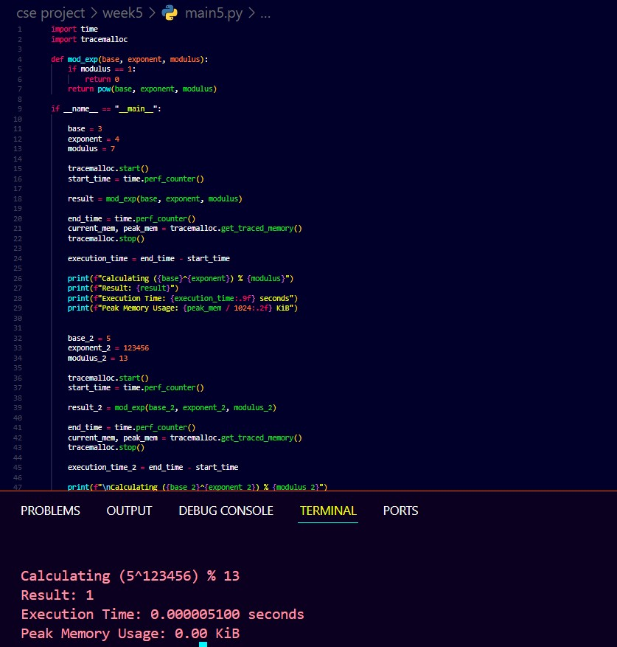

SKILLS ACHIEVED:
- Understanding the concept and utility of modular exponentiation.
- Knowing and using the correct built-in function (pow(b, e, m)) for an optimized mathematical operation.
- Appreciating the difference between a naive calculation and an efficient algorithm.

